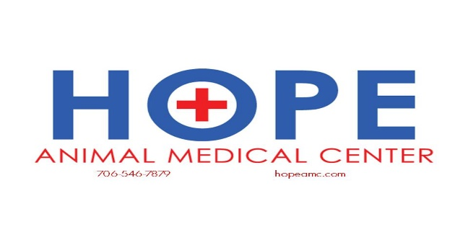

Comprehensive Oral Health Assessment and Treatment (COHAT)
Most clients do not realize that the quality of dental services vary tremendously from one veterinary hospital to another.

Dentistry at Hope Animal Medical Center has evolved over the years as our doctors have become more educated about oral health and the overall impact dental and periodontal disease can have on the well-being and comfort of our patients.

Because each veterinary care facility offers a different level of dental care, comparing services on price alone does not necessarily allow you to fully evaluate the treatment your pet will receive.

At Hope Animal Medical Center, a team of three staff members work to provide the safest and best possible care for your pet.
- A veterinarian oversees the entire dental procedure, performing extractions and dental surgery as needed.
- A registered veterinary technician (RVT) takes dental X-rays and performs the cleaning.
- An additional assistant monitors anesthesia.

A Comprehensive Oral Health Assessment and Treatment (COHAT) procedure at Hope Animal Medical Center includes:

General anesthesia
- General anesthesia is required to perform a thorough oral exam and cleaning as well as obtain dental X-rays.
- Anesthetic monitoring equipment includes EKG to monitor the heart, blood pressure monitoring, pulse oximetry to monitor oxygenation and ETCO2 to monitor carbon dioxide levels.

Anesthetic safety and supportive techniques
- The use of an IV catheter allows for fluid support and rapid medication administration, if necessary.
- A Bair Hugger blanket is used during the procedure to support core body temperature, which is essential for safe anesthesia and recovery.

Full-mouth dental X-rays
- Radiographs (X-rays) are obtained to further detail the health of the teeth below the gum line and determine the extent of periodontal disease. Studies show that less than 50 percent of all dental problems in dogs and cats can be identified without dental X-rays.
- Full-mouth dental X-rays are especially important for small breed dogs and cats or those pets with a history of periodontal disease.

Dental cleaning and treatment
- A registered veterinary technician (RVT) performs the dental cleaning procedure, which includes ultrasonic and hand scaling, polishing and complete dental charting.

Oral surgery and extractions
- After the dental X-rays are reviewed by the veterinarian, recommendations for extractions or oral surgery are discussed with the owner by phone.
- All oral surgery and extractions are performed by the veterinarian.
- Pre-emptive pain control, including dental nerve blocks and systemic pain medication, allows your pet to remain comfortable during and after recovery.

What to expect after the procedure:
- Our staff will review tooth brushing and home care recommendations with you to maintain your pet’s oral health.
- Most pets are sedate for the evening following a dental procedure, but will return to normal behavior the next day.
- We may recommend feeding a soft diet for a few days for pets requiring oral surgery. These pets are also sent home with pain medication and antibiotics.

