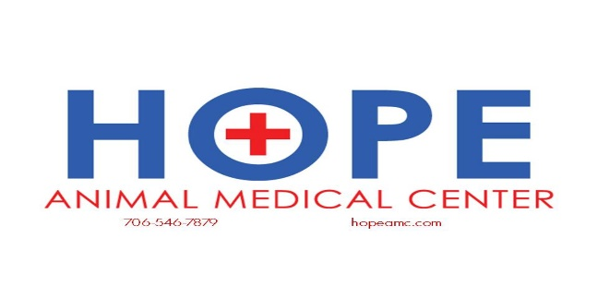

Feline Hyperthyroidism
What is hyperthyroidism?
The thyroid gland is located in the neck and plays a very important role in regulating the body's rate of metabolism. Hyperthyroidism is a disorder characterized by the overproduction of thyroid hormones and a subsequent increase in the metabolic rate. This is a fairly common disease of older cats.

Although this condition causes the gland to enlarge, it is usually a benign change; less than two percent of hyperthyroid cases involve a malignant change in the gland.

Many organs are affected by this disease, including the heart. Hyperthyroidism stimulates the heart to pump faster and more forcefully, and eventually, the heart enlarges to meet these increased demands for blood flow. The increased pumping pressure leads to a greater output of blood and high blood pressure. About 25 percent of cats with hyperthyroidism also have high blood pressure (hypertension).

Which cats are most likely to become hyperthyroid?
A cat is at increased risk for hyperthyroidism with advancing age. Environmental and dietary risk factors may also play a role in predisposing cats to hyperthyroidism, though the specific mechanisms are not known. No individual breed is known to be especially at increased risk, but the Siamese appears to have shown an increased incidence of developing hyperthyroidism than other breeds.

What are the clinical signs?
The typical cat with hyperthyroidism is middle aged or older; on average, affected cats are about 12 years of age. The most consistent finding with this disorder is weight loss due to the increased rate of metabolism. The cat tries to compensate for this with an increased appetite. In fact, some hyperthyroid cats have a ravenous appetite and will literally eat anything in sight! Despite the increased intake of food, most cats still lose weight. The weight loss may be so gradual that some owners will not even realize it has occurred or it may be quite rapid.

Affected cats often drink a lot of water and frequently urinate. There may also be periodic vomiting or diarrhea, and the hair coat may appear rough or unkempt. In some cats, anorexia develops as the disease progresses.

Two secondary complications of this disease can be significant. These include hypertension and a heart disease called thyrotoxic cardiomyopathy. Hypertension develops as a consequence of increased pumping within the heart. In some cats, the blood pressure can become so high that retinal hemorrhage or detachment will occur and result in blindness. Heart problems often develop because the heart must enlarge and thicken to meet the increased metabolic demands. However, both of these problems are reversible with appropriate treatment of the disease.

What causes hyperthyroidism?
While some risk factors may point to hyperthyroidism, a specific cause has not been identified. The possible role of dietary iodine continues to be investigated as an influence on the development of hyperthyroidism.

How is it diagnosed?
In most instances, diagnosis of this disease is relatively straightforward. The first step is to determine the blood level of one of the thyroid hormones, called thyroxine or T4. Usually, the T4 level is so high that there is no question as to the diagnosis. Occasionally, a cat suspected of having hyperthyroidism will have T4 levels within the upper range of normal cats. When this occurs, a second test, called a T3 Suppression Test, is performed. If this is not diagnostic, a thyroid scan can be performed at a veterinary referral center or the T4 can be measured again in a few weeks.

What are my options for treatment?
Because less than two percent of hyperthyroid cats actually have cancerous growths of the thyroid gland, treatment is usually very successful. Traditional methods of managing the disease include medication, surgery and radioactive iodine therapy. Oral anti-thyroid drugs are used to control hyperthyroidism and must be given daily, whereas surgical thyroidectomy and radioactive iodine therapy are designed to provide permanent solutions. In addition, recent studies document that dietary treatment now exists for hyperthyroid cats.

Many factors must come into consideration when choosing the best therapy for an individual cat, and when possible, tests are done before adopting any form of treatment. These tests are needed to evaluate the overall health of the cat and predict the chances for complications. Such tests include blood tests, urinalysis, and radiography (X-rays); if available, an electrocardiogram (EKG), blood pressure test and cardiac ultrasound can also be performed.
- Radioactive iodine: The most effective way to treat feline hyperthyroidism is with radioactive iodine therapy. It is given by injection and destroys all abnormal thyroid tissue without endangering other organs. Treatment requires hospitalization at a veterinary clinic licensed to administer radiation therapy. Recurrence of the disease is uncommon after radioactive iodine therapy.
- Oral medication: Administration of an oral drug, methimazole, can control the effects of the overactive thyroid gland. A small number of cats (less than 20 percent) have a reaction to this drug. The side effects may begin as late as six months after starting treatment and can include vomiting, lethargy, anorexia, fever and anemia. Methimazole does not destroy the abnormal thyroid tissue; rather, it prevents the production of excess thyroid hormones. To be truly effective, the drug must be given for the remainder of the cat's life. Periodic blood tests must also be done to keep the dosage regulated. This type of treatment is appropriate for the cat who is a poor surgical candidate due to other health problems or is exceptionally old. Oral medication may also be used for a few weeks to stabilize a cat who is at increased surgical risk because of cardiac complications. Recurrence of the disease is a possibility in some cats.
- Dietary treatment: Research at Hill’s Pet Nutrition has found that feeding a low-iodine food decreases thyroid hormone concentrations and alleviates clinical signs of feline hyperthyroidism. Three studies have documented the safety and efficacy of Hill’s Prescription Diet y/d Feline in cats with naturally occurring hyperthyroidism. The results of these studies support the idea that therapeutic food with dietary iodine levels at or below 0.32 parts per million provides an effective and safe therapy for hyperthyroid cats.
- Surgery: Surgical thyroidectomy is the removal of the thyroid glands. This method is rarely used because less invasive methods are avalable.

What is the prognosis?
Many owners of cats with hyperthyroidism are hesitant to opt for radiation therapy because of the cat's advanced age. It is important to remember, however, that old age is not a disease. The outcomes following radiation therapy are usually excellent and most cats have a very good chance of returning to a normal state of health.

Can hyperthyroidism be prevented?
There are currently no preventive measures for feline hyperthyroidism. However, all middle-aged and geriatric cats should receive a complete physical examination by a veterinarian every six to 12 months and special attention should be given to thyroid enlargement and the clinical signs of hyperthyroidism.

